http://toolboxes.flexiblelearning.net.au/index.htm

Contents
Contents
Introduction to the transport industry 2
Goods, cargo and a range of delivery sites 5
2.1 What are the characteristics of loads? 5
2.2 Builder's Paradise - Pickup and delivery of building products 5
2.3 Carrying concrete 5
2.4 Market day - Pickup and delivery of produce from a wholesale market 6
2.5 Where are my load restraints? 6
2.6 Packing, loading and driving 6
2.7 Different drop points - Road transport 7
Load capacity, weight and mass 7
3.1 How much weight can I put on a vehicle? 7
3.2 How do I work out load weights? 7
3.3 How do I carry a load safely? 8
3.4 What are the causes of load shift? 8
Securing and restraining cargo and goods 8
4.1 What are the load restraint methods? 8
4.2 How do I tie down a load using ropes? 9
4.3 How many ropes do I need? 9
4.4 How do I tie down a load with webbing? 10
4.5 How many webbing straps do I need? 10
4.6 How do I tie down a load using chains? 10
4.7 How many chains do I need? 11
4.8 How do I increase the load grip? 11
5.1 Oil spill on the load deck 12

This course includes the following sections:
An introduction to the transport industry and information on chain of responsibility and delivery documentation;
An outline of the types and characteristic of cargos and goods and range of different delivery sites;
Load capacity and how to calculate load weight and placement to safely load and transport goods and cargo;
How to secure and restrain various loads using a number of methods; and
Housekeeping and cleaning example.

Most of the content has been downloaded from a site called the (Australian) National Vet Content which was related to Flexible learning toolboxes. These sites are no longer available after 30/06/16 and as such the content has been uploaded here to enable the free access and use of these resources. Some of the links may no longer work and some references may be outdated, especially if units of competency are embedded or noted. However, the overall content is still valuable and you are advised to ensure related legislative and regulatory requirements are current and relevant to your location.

Enjoy and remember load safety is road safety!

Introduction to the transport industry

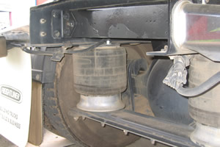 | Glossary - Road Transport(Modified on Tue 30 Sep 2014 11:17:18)  This is the glossary for the Road Transport terminology particularly addressing terms from the TDTD497B Load and unload goods/cargo competency unit.  Competency: TDTD497B Load and unload goods/cargo  Educational Level: Certificate II  Training Package: Transport and Distribution  Toolbox: 708 - Road Transport

First day on the job - Road transport(Modified on Tue 30 Sep 2014 11:18:20)
This practice activity covers the first day on the job as a driver with an emphasis on chain of responsibility and documentation.
Competency: TDTD497B Load and unload goods/cargo
Educational Level: Certificate II
Training Package: Transport and Distribution
Toolbox: 708 - Road Transport

Who is responsible for loading and unloading?(Modified on Tue 30 Sep 2014 11:18:27)
This learning activity covers the chain of responsibility from the point of view of individual job roles in a typical transport company.
Competency: TDTD497B Load and unload goods/cargo
Educational Level: Certificate II
Training Package: Transport and Distribution
Toolbox: 708 - Road Transport

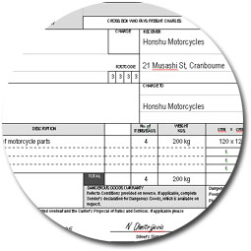 | What documentation do I need? - Road Transport(Modified on Tue 30 Sep 2014 11:18:18)  This learning activity covers the documentation that an operator would use in the course of making a delivery, especially con notes, run sheets and pre-trip checklists.  Competency: TDTD497B Load and unload goods/cargo  Educational Level: Certificate II  Training Package: Transport and Distribution  Toolbox: 708 - Road Transport

Goods, cargo and a range of delivery sites

2.1 What are the characteristics of loads?
1  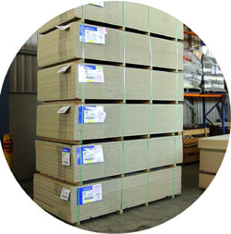 | What are the characteristics of loads?(Modified on Tue 30 Sep 2014 11:17:04)  This learning activity covers characteristics of loads, specifically: palletised loads and packs, cylindrical loads like drums, pipes, tubes and rods.  Competency: TDTD497B Load and unload goods/cargo  Educational Level: Certificate II  Training Package: Transport and Distribution  Toolbox: 708 - Road Transport

2
2.2 Builder's Paradise - Pickup and delivery of building products(Modified on Tue 30 Sep 2014 11:17:06)
This practice activity covers the pickup and delivery of building products with an emphasis on chain of responsibility, documentation, load positioning and restraint.
Competency: TDTD497B Load and unload goods/cargo
Educational Level: Certificate II
Training Package: Transport and Distribution
Toolbox: 708 - Road Transport
3
2.3 Carrying concrete(Modified on Tue 30 Sep 2014 11:18:24)
This practice activity covers the pickup and delivery a load of palletised concrete bags with an emphasis on chain of responsibility, calculating load weight and load capacity, load positioning and restraint.
Competency: TDTD497B Load and unload goods/cargo
Educational Level: Certificate II
Training Package: Transport and Distribution
Toolbox: 708 - Road Transport

4
2.4 Market day - Pickup and delivery of produce from a wholesale market(Modified on Tue 30 Sep 2014 11:18:26)
This practice activity covers the pickup and delivery of produce from a wholesale market with an emphasis on chain of responsibility, load positioning and restraint.
Competency: TDTD497B Load and unload goods/cargo
Educational Level: Certificate II
Training Package: Transport and Distribution
Toolbox: 708 - Road Transport

5
2.5 Where are my load restraints?(Modified on Tue 30 Sep 2014 11:17:01)
This practice activity covers the pickup and delivery of electrical goods with an emphasis on chain of responsibility and load restraint.
Competency: TDTD497B Load and unload goods/cargo
Educational Level: Certificate II
Training Package: Transport and Distribution
Toolbox: 708 - Road Transport
6
2.6 Packing, loading and driving(Modified on Tue 30 Sep 2014 11:17:27)
This practice activity covers the pickup and delivery of computer parts with an emphasis on documentation and selection of a suitable vehicle.
Competency: TDTD497B Load and unload goods/cargo
Educational Level: Certificate II
Training Package: Transport and Distribution
Toolbox: 708 - Road Transport
7
2.7 Different drop points - Road transport(Modified on Tue 30 Sep 2014 11:17:27)
This practice activity covers the pickup and delivery of a load of stationery supplies to multiple drop points, with an emphasis on chain of responsibility, documentation, load positioning and restraint.
Competency: TDTD497B Load and unload goods/cargo
Educational Level: Certificate II
Training Package: Transport and Distribution
Toolbox: 708 - Road Transport

Load capacity, weight and mass

3.1  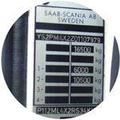 | 3.1 How much weight can I put on a vehicle?(Modified on Tue 30 Sep 2014 11:17:26)  This learning activity covers the method of calculating load weight to determine whether it is within the load capacity of a vehicle.  Competency: TDTD497B Load and unload goods/cargo  Educational Level: Certificate II  Training Package: Transport and Distribution  Toolbox: 708 - Road Transport

3.2  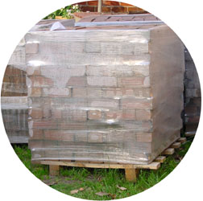 | 3.2 How do I work out load weights?(Modified on Tue 30 Sep 2014 11:17:25)  This learning activity covers the load weights of general freight, specifically: palletised freight, packs, bundles, coils and drums.  Competency: TDTD497B Load and unload goods/cargo  Educational Level: Certificate II  Training Package: Transport and Distribution  Toolbox: 708 - Road Transport
3.3
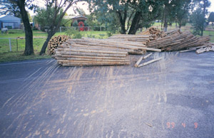 | 3.3 How do I carry a load safely?(Modified on Tue 30 Sep 2014 11:18:25)  This learning activity covers load positioning and distribution of load weight.  Competency: TDTD497B Load and unload goods/cargo  Educational Level: Certificate II  Training Package: Transport and Distribution  Toolbox: 708 - Road Transport

3.4  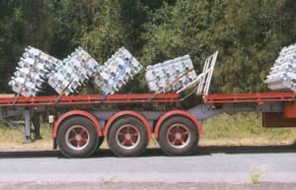 | 3.4 What are the causes of load shift?(Modified on Tue 30 Sep 2014 11:16:59)  Generally, there are six factors that cause the load to shift or move on a vehicle: Sudden braking and accelerating; Cornering; Hills and undulating roads; Uneven road surfaces; Adverse road camber; Wind and airflow over the vehicle.  Competency: TDTD497B Load and unload goods/cargo  Educational Level: Certificate II  Training Package: Transport and Distribution  Toolbox: 708 - Road Transport

Securing and restraining cargo and goods

4.1 | 4.1 What are the load restraint methods?(Modified on Tue 30 Sep 2014 11:17:02)  This learning activity covers the methods of restraining loads, specifically: attaching, containing, blocking and tying down with lashings.  Competency: TDTD497B Load and unload goods/cargo  Educational Level: Certificate II  Training Package: Transport and Distribution  Toolbox: 708 - Road Transport
4.2
4.2 How do I tie down a load using ropes?(Modified on Tue 30 Sep 2014 11:18:19)
This learning activity covers the equipment, knowledge and techniques that you need to know in order to tie down a load with ropes.
Competency: TDTD497B Load and unload goods/cargo
Educational Level: Certificate II
Training Package: Transport and Distribution
Toolbox: 708 - Road Transport
4.3  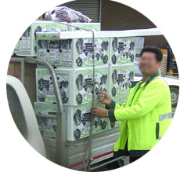 | 4.3 How many ropes do I need?(Modified on Tue 30 Sep 2014 11:18:22)  This learning activity covers the method of calculating the number of ropes needed to tie down loads of different weight and dimensions.  Competency: TDTD497B Load and unload goods/cargo  Educational Level: Certificate II  Training Package: Transport and Distribution  Toolbox: 708 - Road Transport

4.4
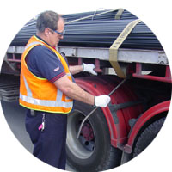 | 4.4 How do I tie down a load with webbing?(Modified on Tue 30 Sep 2014 11:17:10)  This learning activity covers the equipment, knowledge and techniques that you need to know in order to tie down a load with webbing straps.  Competency: TDTD497B Load and unload goods/cargo  Educational Level: Certificate II  Training Package: Transport and Distribution  Toolbox: 708 - Road Transport

4.5  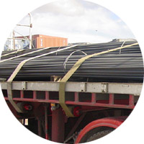 | 4.5 How many webbing straps do I need?(Modified on Tue 30 Sep 2014 11:18:18)  This learning activity covers the method of calculating the number of webbing straps needed to tie down loads of different weight and dimensions.  Competency: TDTD497B Load and unload goods/cargo  Educational Level: Certificate II  Training Package: Transport and Distribution  Toolbox: 708 - Road Transport

4.6  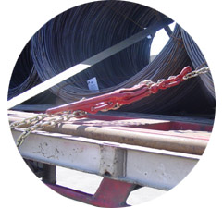 | 4.6 How do I tie down a load using chains?(Modified on Tue 30 Sep 2014 11:17:15)  This learning activity covers the equipment, knowledge and techniques that you need to know in order to tie down a load with a dog and chain.  Competency: TDTD497B Load and unload goods/cargo  Educational Level: Certificate II  Training Package: Transport and Distribution  Toolbox: 708 - Road Transport

4.7

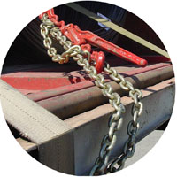 | 4.7 How many chains do I need?(Modified on Tue 30 Sep 2014 11:18:27)  This learning activity covers the method of calculating the number of chains needed to tie down loads of different weight and dimensions.  Competency: TDTD497B Load and unload goods/cargo  Educational Level: Certificate II  Training Package: Transport and Distribution  Toolbox: 708 - Road Transport
4.8
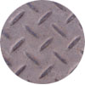 | 4.8 How do I increase the load grip?(Modified on Tue 30 Sep 2014 11:18:17)  This learning activity covers load grip or friction. Ways of improving the load grip and minimising slippage are examined.  Competency: TDTD497B Load and unload goods/cargo  Educational Level: Certificate II  Training Package: Transport and Distribution  Toolbox: 708 - Road Transport

5.1 Oil spill on the load deck(Modified on Tue 30 Sep 2014 11:17:11)
This practice activity covers the disposal of damaged goods and the pickup and delivery of non-unitised freight, with an emphasis on chain of responsibility, load positioning and restraint.
Competency: TDTD497B Load and unload goods/cargo
Educational Level: Certificate II
Training Package: Transport and Distribution
Toolbox: 708 - Road Transport

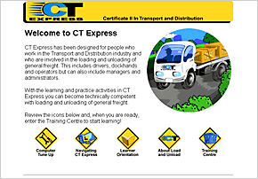 | Road Transport (708) TOOLBOX(Modified on Mon 31 Aug 2015 23:37:04)  The tasks associated with the Certificate II in Transport and Distribution Toolbox are based on real situations found in road transport locations nationwide. These tasks aim to provide an authentic learning experience that relates to the work environment that the learner has or will encounter.  The Road Transport Industry is heavily regulated and as such, there is a demand for quality training in all areas of loading and unloading cargo. The ...  Competency: TDTD497B Load and unload goods/cargo, TDTA197B Secure cargo (Partial), TDTA897B Transfer cargo (Partial), TDTE597B Carry out basic workplace calculations (Partial), TDTE297B Estimate/Calculate mass, area and quantity dimensions (Partial)  Training Package: Transport and Distribution  Toolbox: 708 - Road Transport

Others to do and get
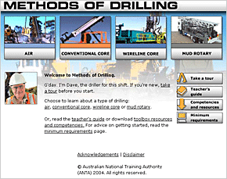 | Method of Drilling (706) TOOLBOX(Modified on Tue 25 Aug 2015 21:30:02)  The Methods of Drilling Toolbox introduces new starters, people who have just completed their on-site induction and have started as assistant drillers on site, to the knowledge and experience required for driller’s assistants. The learner selects the drilling method that they use on site, and work their way through preparations, operations and sampling on a typical drill site.  The Toolbox utilises multimedia to provide a rich, immersive learning experience. After an ...  Competency: DRTNHB08A Assist air drilling, DRTNHB11A Assist conventional core drilling, DRTNHB12A Assist wireline core drilling, DRTNHB15A Assist mud rotary drilling  Training Package: Drilling Industry  Toolbox: 706 - Methods of Drilling

